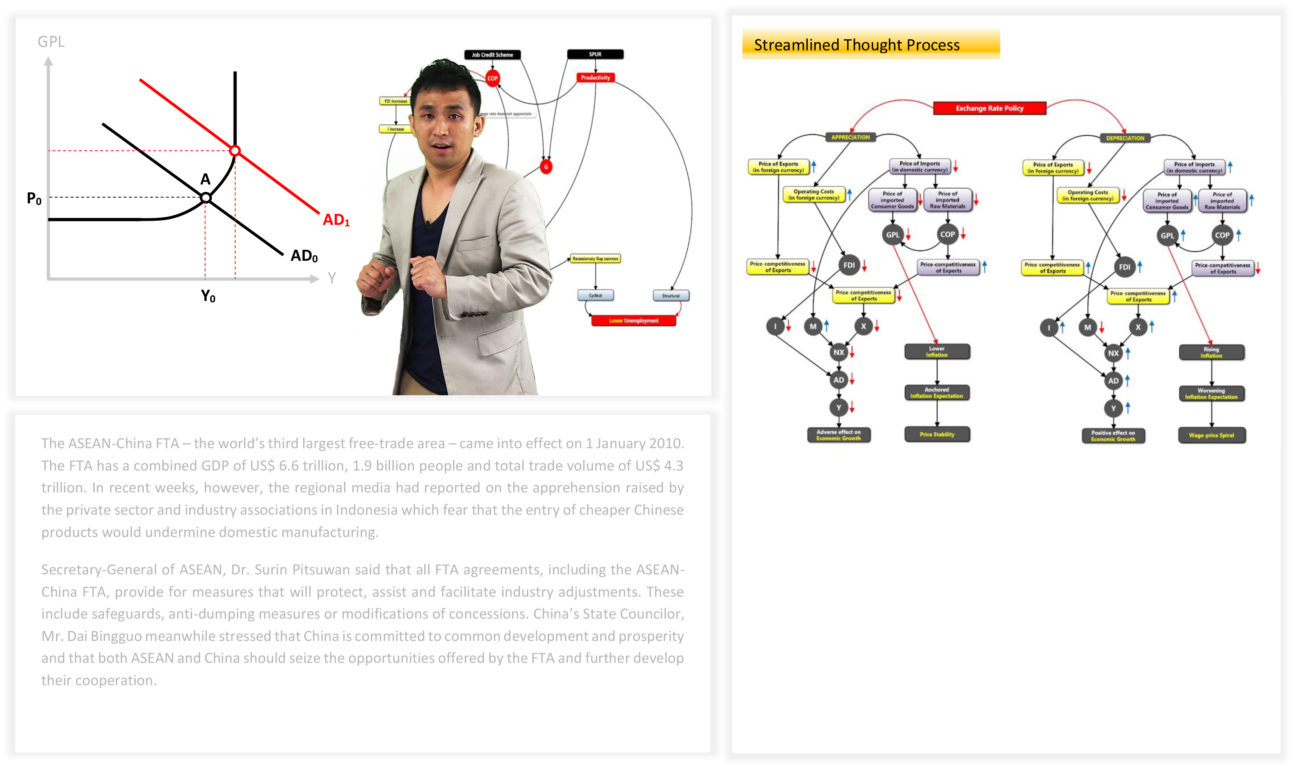
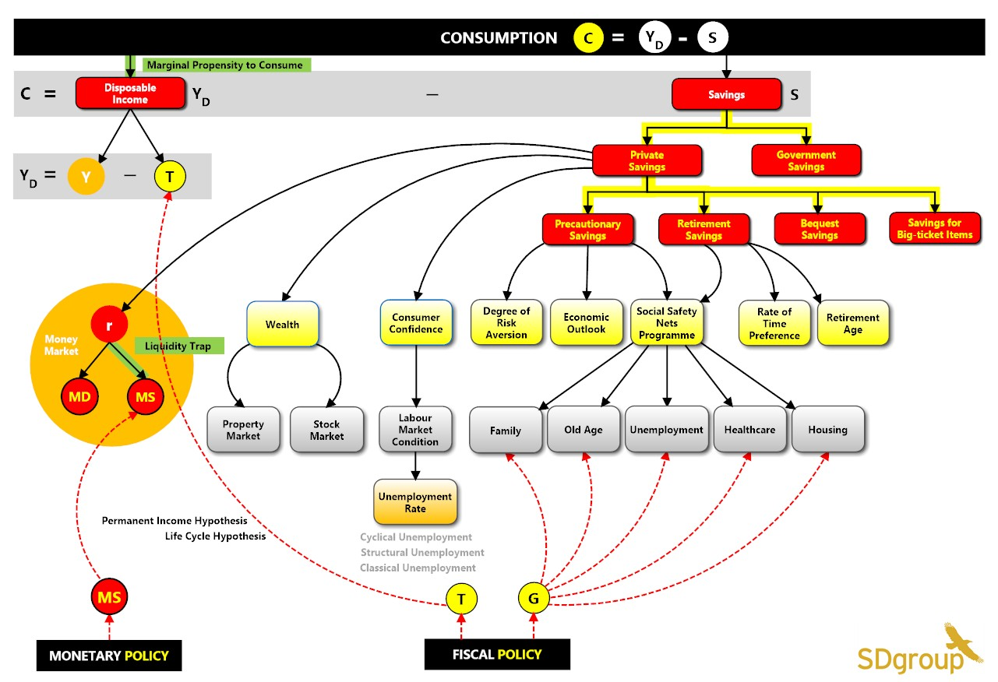
Concepts
SG

APC
MPC
Since global demand plays a strong role in driving Singapore’s economy, the outlook for Singapore looked positive as 2011 began. In the 2010 Annual Economic Survey of Singapore released in February 2011, policy makers were optimistic about Singapore’s prospects for 2011. The strong sequential expansion in Singapore over the previous few quarters had lent strong momentum. Moreover, several factors looked set to support good growth. First, most analysts expected an acceleration in US economic growth from 2.9% in 2010 to 3.2% in 2011. Second, domestic demand in Asia was proving resilient. Third, new production capacity in a number of manufacturing clusters was beginning to flow while the integrated resorts which had just been opened were expanding their contribution to Singapore’s economy. Consequently, the Ministry of Trade and Industry (MTI) projected Singapore’s economy to grow between 4% and 6% in 2011, a respectable rate of growth after the near 15% expansion in 2010.

Despite the apparent optimism, the outlook for 2011 was not without risks.

First, the impact of the global crisis in 2009 on the developed economies, which together comprised half of the global economy, remained deep.

Video
Reply
Reply
Reply
Hi, I don’t understand why the government must borrow money.

I agree with Alex. Why can’t the government just print more money to pay for the expenses?
Administrator

Please look at attached video for details.

Admin

Daniel Soh

Alex Lin:

